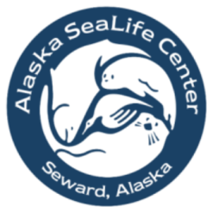

Outreach Program Reservation Form

Program Information: (Please fill out a separate form for each presentation date)

Preferred presentation date:
Alternate date:

 | Time | Program | Teacher’s name | # of students | Grade(s)
1st Program
2nd Program
3rd Program
4th Program
Additional program notes/questions:

You may reserve a maximum of four presentations each day (each classroom program has a limit of 30 students). A minimum of 10 minutes between presentations is requested. Please ensure all information is entered below. Information about our programs, including costs, can be found on our website (www.alaskasealife.org). Simultaneous programs requiring two or more presenters will incur additional charges, as will gaps of more than 1¼ hours between presentations.

Contact Information:

Location
School/Organization:
Physical Address:
City, State, Zip:
Phone Number:
Lead Contact Person
Name:
Phone Number:
E-mail address:
Billing Information
School/Organization:
Billing Contact Name:
Phone Number:
E-mail address:
Street Address:
City, State, Zip:

After completing this form, e-mail it to outreach@alaskasealife.org
or fax it to (907) 224-6320.

Questions? Contact us at (907) 224-6306

